Benefits of Outdoor Play for Young Children
Children who play outside regularly have been found to be happier and healthy than those with an inside sedentary lifestyle. By encouraging children to spend time outdoors you are allowing them to experience weather and seasonal changes, build their immune system, take in important vitamin D, learn to take risks and challenge themselves physically.
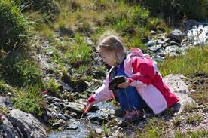
According to research (Fjortoft 2004; Burdette and Whitaker 2005), children who play outdoors regularly:
• Become fitter and leaner
• Develop stronger immune systems
• Have more active imaginations
• Have lower stress levels
• Play more creatively
• Have greater respect for themselves and others

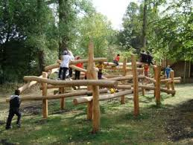
Outdoor play is a fantastic opportunity for children to move freely and in a wider space, encountering physical challenges that are limited during indoor play. Children take more risks and expand their physical skill set with challenge play as they utilise gross motor equipment in a safe environment. Children learn to manoeuvre their bodies and equipment whilst avoiding obstacles, changing directions and speed. They explore a greater range of level play and develop a range of movements including climbing, crawling, balancing, running, stooping and so on.

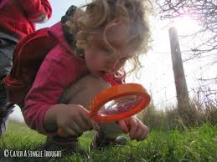
They explore and investigate nature and the environment and how they change, grow and develop over time. They look at cause and effect, similarities and differences, patterns and natural occurrences. Outdoor play allows children to discover and learn in a hands on environment that is naturally stimulating. It allows them to make their own decisions and create their own goals. It helps to develop language skills and problem solving as children feel freer and more relaxed.
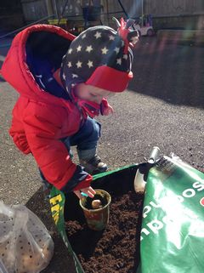
Outdoor play helps to develop immune systems and strengthen children’s bodies making them much more resilient and prepared for illnesses. Children who play outside are exposed to dirt and germs that build their immunity to stronger bugs and the fresh air and space for exercise allow their lungs to become strong and improves their muscle health.
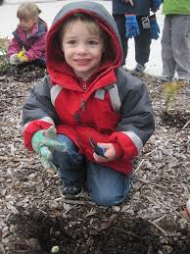
Children who have the opportunity to play outside regularly are able to balance their moods and understand them better. They are able to release any pent up energy and emotions in a freeing environment where they often feel less restricted and allow themselves to explore physically, creatively and emotionally. They express themselves with more description and confidence.

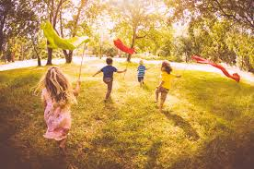
Children who are given the opportunity to experience all weather types become more experienced people as they grow. They are confident to try new things and have a wider view of the changing world around them allowing them to gain and retain their knowledge gathered. They try new things with a more hands on approach and develop life skills that they can apply to different aspects of their daily life.

At Little Blossoms we aim to explore all aspects of the outside world, whether out for a walk in the surrounding areas or in the setting gardens area. We look at providing a healthy approach to physical play allowing children to develop at their own pace and become part of their own risk assessments and challenges. We like to explore nature as close as we can and take note of the changes we see around us. We also enjoy experiencing the changing seasons and weather trying new ways to investigate what happens.

Benefits of Outdoor Play for Young Children
Links to the EYFS:
Characteristics of Effective Learning:
Playing and Exploring - engagement
Finding out and exploring
• Showing curiosity about objects, events and people • Using senses to explore the world around them • Engaging in open-ended activity • Showing particular interest
Playing with what they know
• Pretending objects are things from their experience • Representing their experiences in play • Taking on a role in their play • Acting out experiences with other people
Being willing to ‘have a go’
• Initiating activities • Seeking challenge • Showing a ‘can do’ attitude • Taking a risk, engaging in new experiences, and learning by trial and error
Active Learning - motivation
Being involved and concentrating
• Maintaining focus on their activity for a period of time • Showing high levels of energy, fascination • Not easily distracted • Paying attention to details
Keeping on trying
• Persisting with activity when challenges occur • Showing a belief that more effort or a different approach will pay off • Bouncing back after difficulties
Enjoying achieving what they set out to do
• Showing satisfaction in meeting their own goals • Being proud of how they accomplished something – not just the end result • Enjoying meeting challenges for their own sake rather than external rewards or praise
Creating and Thinking critically - thinking
Having their own ideas
• Thinking of ideas • Finding ways to solve problems • Finding new ways to do things
Making links
• Making links and noticing patterns in their experience • Making predictions • Testing their ideas • Developing ideas of grouping, sequences, cause and effect
Choosing ways to do things
• Planning, making decisions about how to approach a task, solve a problem and reach a goal • Checking how well their activities are going • Changing strategy as needed • Reviewing how well the approach worked

