Hello to our children and their parents,
The wetter weather is now upon us, so could you please provide wellies and a waterproof jacket for outside play. Please ensure these are CLEARLY LABELLED to ensure children are only wearing their own belongings. Preschool do aim to go outside at least twice a day so we need to be prepared. We also ask that you dress your child in appropriate clothing for the time of year and we also ask that you provide your child with spare clothes, underwear and nappies/pull up’s (if needed) in case of any accidents or messy play activities where your child will need to be changed. We will be getting wet and enjoying water and messy play!
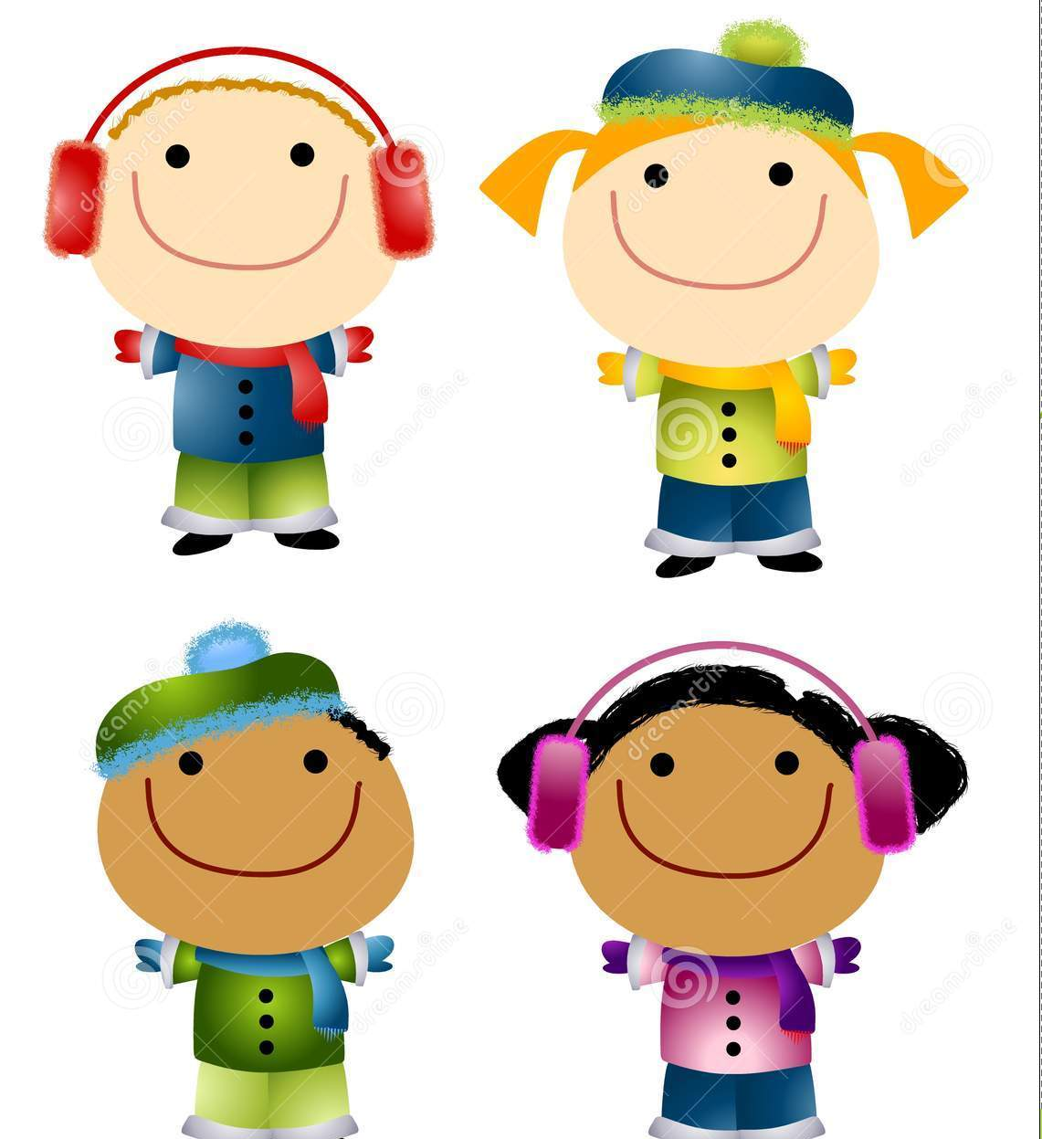
Wellies and Waterproofs!!
Welcome back to all our families after the summer holidays, we hope you have all had a fantastic time together! The new term is now upon us and Little Blossoms have lots of fun and exciting things to try out and activities to do:
This coming term we will be looking at ourselves and our families, talking about what we look like, our body parts, who we live with, where we live, what we like and dislike and how trying new things can be fun. We will be singing songs to learn where our ‘heads, shoulders, knees and toes are and ‘the way we wash our face and brush our teeth.’ We will be exploring our faces and the colours of our eyes, skin and hair. We will be learning about our differences and similarities to our friends. We will be exploring resources and finding out our favourites and how we play and learn. We will look at how we can practice our independence and new skills that we can discover and practice. We will be looking at houses and match them to those around the world and have discussions about how we live and how others may live.
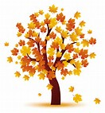
In October we will be looking at the changing season of Autumn. We will explore how the leaves change colour, fall from the trees and become crunchy and dry. We will look at hibernating animals such as hedgehogs and investigating where they live. We will be hunting for conkers and pine cones to create our own autumn animals and play landscapes. We will be enjoying mixing our autumnal colours to create beautiful artwork. We will venture out into the wide world to feel the changing weather, the wind blowing the cooler air around. We will talk about Harvest time and explore the seasonal fruits and vegetables ready to eat and have a go at cooking something delicious. We will have lots of fun creating Halloween bats and potions, carving pumpkins and dressing up.
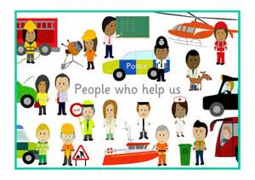
In November we will be learning about people who help us such as Firefights, Police Officers, Doctors and Nurse, Teachers, Shop Assistants. We will look at what they do, if they wear special clothing, if they drive a special vehicle. We will learn about fire safety, crossing the road and how to look after others. We will discuss how people help each other and what we can do to help our friends and families and our feelings. We will also be taking a look at the festival of Diwali and the lights and colours surrounding the story of Rama and Sita and exploring the colours and sparkle of Bonfire night.
In December we will be enjoying the festive season, creating cards, baubles for trees and exploring a variety of customs and traditions such as baby Jesus, St Nicholas and Hanukah. We will be singing festive songs and dressing up and having lots of party fun before the end of the year.

We would love to hear from our families and all the exciting things you have been getting up to at home or out and about or on your holidays so please feel free to bring in any photographs or interesting objects so we can talk about them with your children and their friends during circle time.

Here are some fun ideas to do at home or out and about this term:
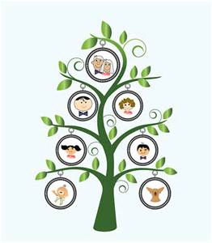
Create a family tree using photographs of people in your family. Talk about each person and how they are related to you.
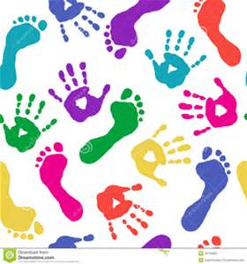
Make a family hand and foot print collage. Choose your favourite colours and use a long strip of paper to create a messy but fun piece of art!
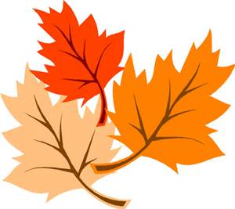
Why not make a leaf blowing picture – go outside and collect a variety of interesting autumn leaves and arrange them on a piece of paper, glue them down. Take a photo of your child from the side blowing, print off, cut out and attach to the side of the picture – it will look like your child is blowing the leaves!
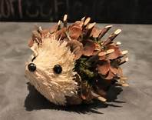
Collect a large handful of autumn leaves and several pine cones and conkers. Place into a tray or arrange on the floor to create your own hibernation landscape!
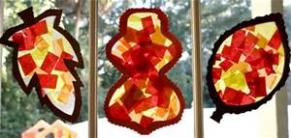
Create an autmn sun catcher using orange, brown, yellow and red tissue paper glued randomly on top of each other and when dry placed against a window.
Talk about how you would get out of your house if there was a fire! What should you take? Where should you go? Who do you call? Practice as a family leaving your house in a fire drill.
Why not play dressing up? Pretend to be docotors and nurses and wrap up each other’s broken bones with bandages, take each other’s temperatures and rub magic cream on bumps and bruises.
Go outside in the dark and enjoy a nice fireworks display (even if it’s not your own) talk about the colours that you see, the sounds that you hear, how cold it is.
Create your own holiday decorations using lots of colours and glitter, get really messy. Add photographs of your family and hang around the house to create a lovely festive atmosphere!

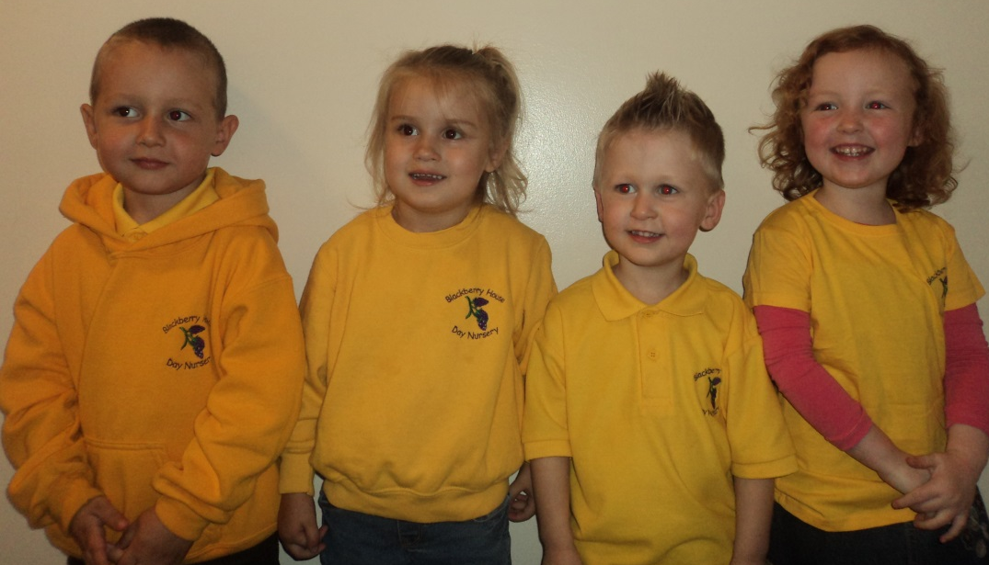
Thank you for your continued support
Little Blossoms Team

